Health processes
Name
Institution
Course
Instructor
Date

EMR/EHR
Electronic Medical Record (EMR) refers to digital charts containing the medical history as well as the history of the treatment of patients. The records can be found in any setting of care practice accessible to a clinician. The patient data and information stored in the EMR can be tracked over a period of time with easy identification of scheduled screenings and check-ups as well as monitoring patient progress. Electronic health records(EHRs) are also used for the same purposes as electronic medical records, except that they encompass a wider aspect of the total health of the patient (Hoerbst, & Ammenwerth, 2019). The EHRs allow healthcare providers to share data through interoperable systems. There are various types of EHR software accessible to the clinicians providing care to patients. Mobile care clinics also need access to health records when providing emergency services to the patients. The EHRs and EMRs can help the clinicians providing care in mobile clinics with better accessibility to the medical history of the patient, treatment plans, as well as the possible allergies and past diagnosis. The proposed mobile clinics need to implement the EHR and EMR systems as a way of improving service provision to the patients. The Columbus healthcare system can work together with the mobile clinics in ensuring the availability of the electronic health/medical records.
Workflow diagram
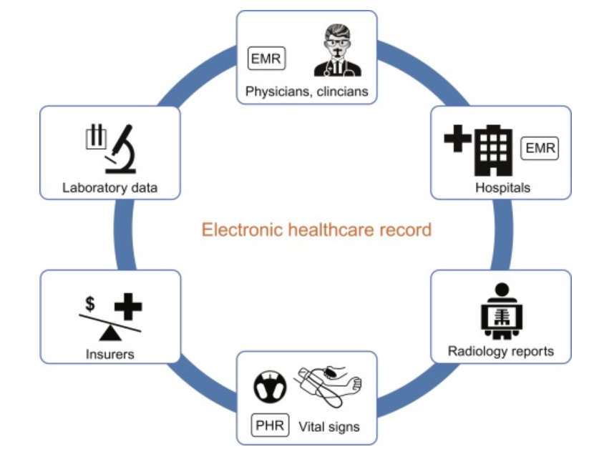

Appointment scheduling
Appointment scheduling is used in the provision of primary care in managing access to the service providers. Appointment scheduling dictates when a certain patient receives a given service. The scheduling of appointments depends on the number of patients in need of the healthcare services as well as the available service providers. Scheduling an appointment with a clinician in a given hospital has been made easier by the development in technology and innovation. Patients do not have to visit the hospitals or clinics to schedule an appointment (Gupta, & Denton, 2018). Rather, there are various types of scheduling software where the patients can schedule appointments with service providers from their homes. This innovation has been significant to the efficiency of service provision in the proposed mobile clinics. The availability of scheduling software allows the clinics to provide services to people living in different areas. The scheduling of appointments in the mobile care clinics is based on the available number of service providers as well as the time taken to travel from one place to another. With the available technology, appointments can be scheduled by visiting the websites of various mobile care service providers. Based on the proximity of the service providers to the patients. The Columbus healthcare system can identify specific regions where mobile care services are necessary and help in appointment scheduling.
Workflow diagram 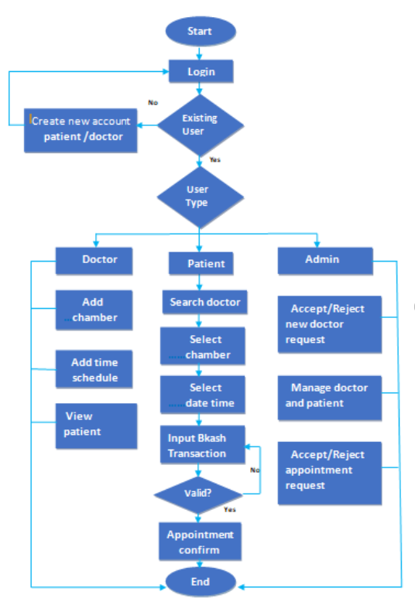

Billing process
The billing process is used in healthcare organizations in claim follow-up with the insurance companies after services are provided to a patient. A billing claim is sent to the insurance company covering the patient to send the payment for the services provided. The medical biller in healthcare has a responsibility of following up the health claim to ensure the workers receive reimbursement for the work they provide (Kliethermes, 2017). The billing process for services provided in a hospital or a mobile clinic is the same. The clinics which provide the services in a mobile care setting are expected to have a medical biller responsible for the follow-up process and the negotiation of payment among all three parties involved. In the Columbus area, over 90% of the citizens are covered by private insurance, Medicaid, as well as military and VA programs. Most of the residents of the region are covered via employee programs. The mobile clinics will need to file the billing claims to these insurers upon the provision of the services to the various patients.
Workflow diagram
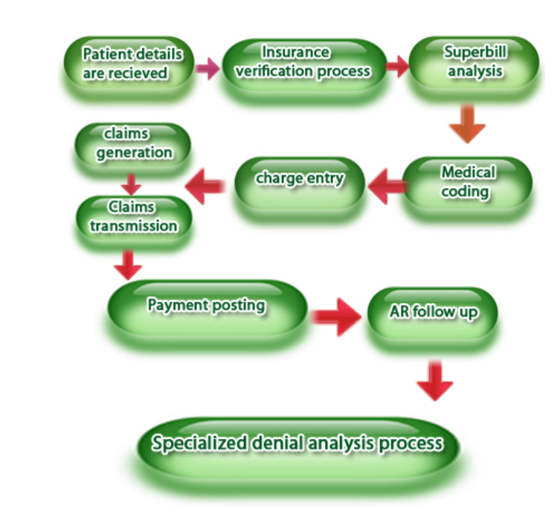Lewin’s model of change management
The proposed changes are aimed at improving service delivery in Columbus. Lewin's model of change management explains the change in three stages. The first stage is unfreezing. This is the stage associated with preparing the organization for the change. It includes the activities which convince the members of the organization that change is necessary (Shirey, 2019). The prevailing status quo is broken down in this stage while the members are motivated to accept the change. In this case, the organization will promote various changes, including the use of EHR systems as well as the use of online scheduling for patient appointments.
The change is the second step in Lewin's model of change. It is the stage where the reach change is implemented. The various resources required for the change will be gathered in this stage. The various actions are taken as a part of implementing the change. The refreeze is the third step that comes after change implementation (Shirey, 2019). In this stage, the change implemented in the organization is embraced and accepted. People encompass the new change in their daily activities, making it the usual way of doing things.

References
Gupta, D., & Denton, B. (2018). Appointment scheduling in health care: Challenges and opportunities. IIE transactions, 40(9), 800-819.
Hoerbst, A., & Ammenwerth, E. (2019). Electronic health records. Methods Inf Med, 49(4), 320-336.
Kliethermes, M. A. (2017). Understanding health care billing basics. Pharmacy Today, 23(7), 57-68.
Shirey, M. R. (2019). Lewin’s theory of planned change as a strategic resource. JONA: The Journal of Nursing Administration, 43(2), 69-72.

